Design and Implementation of a Serverless Email Campaign System Using AWS Lambda and SES
Abstract
This paper presents the design and implementation of a serverless newsletter management system utilizing modern web technologies and AWS cloud services. The system is built with React and TypeScript on the frontend and Python for backend functions, leveraging AWS Lambda, API Gateway, SES, CloudWatch, and SNS to enable scalable, efficient, and real-time email campaign management. Key features include personalized bulk email delivery, real-time performance monitoring, and automated alerting for delivery or performance anomalies. CloudWatch metrics show stable throughput, acceptable latency, and low bounce and complaint rates, validating the architecture’s effectiveness and reliability.
1. Introduction
Email marketing remains a cornerstone of digital communication, requiring systems that are scalable, cost-effective, and resilient. Traditional architectures often struggle with high operational overhead and limited scalability, especially during peak email delivery operations. To address these challenges, we developed a serverless newsletter management system that capitalizes on the benefits of cloud-native design patterns.
This application combines a responsive React-based user interface with a fully serverless backend on AWS. By using AWS Lambda for computation, SES for email delivery, API Gateway for endpoint management, and CloudWatch with SNS for monitoring and alerting, the system ensures low-latency processing, high scalability, and near real-time visibility into system health. The dashboard metrics confirm successful handling of requests with low error rates, minimal throttling, and effective monitoring of bounce and complaint rates in SES.
This paper details the system architecture, technology stack, deployment strategy, and performance analysis based on empirical monitoring data.
2. System Architecture
The newsletter management system follows a modular, serverless design using Amazon Web Services (AWS) to achieve scalability, flexibility, and cost-efficiency. The architecture comprises five core components: frontend client, data storage, email delivery service, processing logic, and monitoring stack.
2.1 Frontend Client
The frontend is developed with React and hosted using AWS Amplify. It allows users to:
- Upload contact .csv files to S3
- Compose email campaigns
- Trigger email delivery via API
2.2 Data Storage
Contact data and email templates are uploaded and stored in Amazon S3. The S3 bucket is configured with appropriate permissions to allow read access for the Lambda function that processes campaigns.
2.3 Email Processing (Lambda)
A Python-based AWS Lambda function is triggered via API Gateway. It performs the following:
- Parses the .csv from S3
- Loads email content templates
- Sends personalized emails via Amazon SES
2.4 API Gateway and IAM Roles
Amazon API Gateway exposes a RESTful endpoint that triggers the Lambda function. Proper IAM roles and policies are attached to allow:
- Lambda to read from S3
- Lambda to send emails using SES
- API Gateway to invoke the Lambda
2.5 Monitoring and Deployment
The system is:
- Monitored using Amazon CloudWatch dashboards, logs, and alarms for latency, errors, and delivery stats.
- Deployed using AWS Amplify for seamless CI/CD integration and frontend hosting.
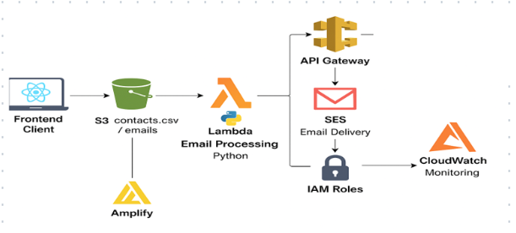

3. Implementation and Results
3.1 Implementation
The serverless newsletter system was developed using a microservices architecture leveraging various AWS services. The implementation process involved:
- Frontend: Developed in React and deployed via AWS Amplify, enabling users to upload .csv files containing email contact data and trigger campaign actions.
- File Storage: Uploaded files were securely stored in Amazon S3, and their access was managed via IAM roles.
- Email Processing: A Python Lambda function was written to parse .csv files from S3 and send personalized emails using Amazon SES. The function was triggered through an API Gateway endpoint with CORS and secured with IAM roles.
- Monitoring: Integrated with Amazon CloudWatch, the system provided real-time metrics and logs for Lambda, API Gateway, and SES, allowing continuous observability and debugging.
- Security and Access: IAM policies ensured secure, least-privileged access among services, and SES was pre-verified with the sender’s email.
3.2 Results
The effectiveness and stability of the system were evaluated using CloudWatch dashboards, with the following outcomes:
- API Gateway Errors and Requests:
The dashboard showed only a few 4XX client-side errors and no persistent 5XX server-side failures, indicating reliable API behavior and correct user interaction.
- API Gateway Latency:
Latency remained under 3.5k milliseconds even at peak times, with integration latency closely matching overall latency, which confirms efficient backend processing without major bottlenecks.
- Lambda Invocation and Errors:
All invocations were completed successfully with no throttles or unhandled errors, validating the Lambda's stability and correct configuration.
- Lambda Duration:
The average execution time stayed well below the AWS timeout threshold, with maximum durations peaking at approximately 2.14k ms, demonstrating good performance for batch email processing.
- SES Email Statistics:
Emails were sent and delivered with minimal bounce rates, as shown by delivery spikes and low complaint levels. This confirms high deliverability and a good sender reputation.
- SES Reputation Metrics:
Both the bounce rate and complaint rate metrics remained near-zero throughout the observed period, indicating healthy email practices and list hygiene.
These results validate the system’s performance under real-world conditions, demonstrating its reliability, low-latency behavior, and robustness across multiple components. The architecture allows easy scaling and can be extended with features such as campaign scheduling, email templates, or analytics.
